**LAB #3**

22k-5195

Task 1:

import java.util.Scanner;  
  
public class task1 {  
 public static void main(String[] args) {  
 Scanner a = new Scanner(System.*in*);  
 int arr[] = new int[10];  
 System.*out*.println("Enter 10 elements");  
 for (int i = 0; i<10 ;i++){  
 arr[i] = a.nextInt();  
 }  
  
 System.*out*.println("Your array: ");  
 for (int i = 0; i< arr.length ;i++){  
 System.*out*.print(arr[i] + " ");  
 }  
  
 for (int i = 0; i < arr.length - 1; i++)  
 {  
 int index = i;  
 for (int j = i + 1; j < arr.length; j++){  
 if (arr[j] < arr[index]){  
 index = j;  
 }  
 }  
 int smallerNumber = arr[index];  
 arr[index] = arr[i];  
 arr[i] = smallerNumber;  
 }  
 System.*out*.println();  
 System.*out*.println("The four minimum values are:");  
 for(int i = 0; i<4;i++){  
 System.*out*.print(arr[i] + " ");  
 }  
  
  
 }  
}

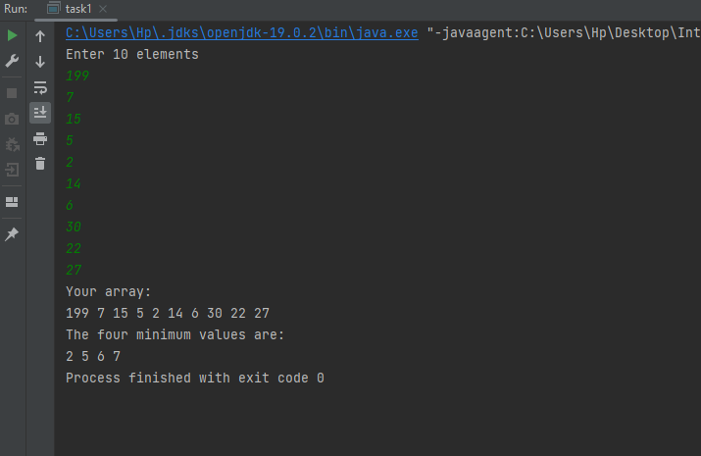

Task 2:

public class task2 {  
 public static void main(String[] args) {  
 int[] arr = {20,12,15,2,10,1,13,9,5};  
  
 System.*out*.println("Before: ");  
 for (int i = 0; i< arr.length ;i++){  
 System.*out*.print(arr[i] + " ");  
 }  
  
 for (int i = 1; i < arr.length; i++) {  
 int key = arr[i];  
 int j = i - 1;  
 while (j >= 0 && arr[j] > key) {  
 arr[j + 1] = arr[j];  
 j = j - 1;  
 }  
 arr[j + 1] = key;  
 }  
 System.*out*.println();  
  
 System.*out*.println("Sorted:");  
 for (int i = 0; i < arr.length; ++i)  
 System.*out*.print(arr[i] + " ");  
  
 System.*out*.println();  
  
 System.*out*.println("Maximum in the middle:");  
 int mid= arr[arr.length-1];  
 for(int i= arr.length-2 ;i> (arr.length)/2;i--){  
 int num = arr[i];  
 arr[i+1] = num;  
  
 }  
 arr[ (arr.length)/2] = mid;  
  
 for (int i = 0; i < arr.length; ++i)  
 System.*out*.print(arr[i] + " ");  
  
 System.*out*.println();  
  
 }  
  
  
}

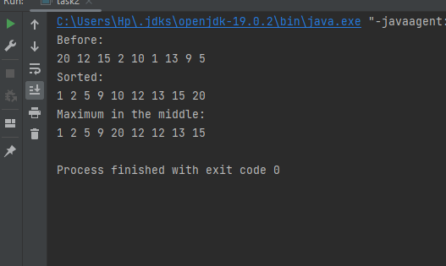

Task 3:

public class task3 {  
 public static void main(String[] args) {  
  
 String[] arr = {"Laiba", "Safi", "Maaz" , "Hani"};  
 System.*out*.println("Your array: ");  
 for (int i = 0; i < arr.length; ++i) {  
 System.*out*.print(arr[i] + " ");  
 }  
  
  
 for (int i = 0; i < arr.length - 1; i++)  
 {  
 int index = i;  
 for (int j = i + 1; j < arr.length; j++){  
 if (arr[j].compareToIgnoreCase(arr[index])<0){  
 index = j;  
 }  
 }  
 String smallerString = arr[index];  
 arr[index] = arr[i];  
 arr[i] = smallerString;  
 }  
 System.*out*.println();  
 System.*out*.println("Sorted:");  
 for (int i = 0; i < arr.length; ++i) {  
 System.*out*.print(arr[i] + " ");  
 }  
 }  
}

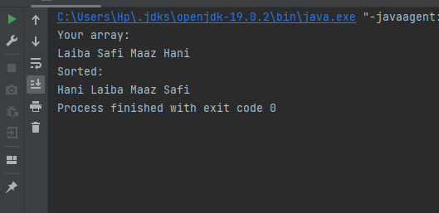

Task 4 :

public class task4 {  
 public static int linearSearch(String[] array, String target) {  
 int steps = 0;  
 for (int i = 0; i < array.length; i++) {  
 steps++;  
 if (array[i].equals(target)) {  
 return i;  
 }  
 }  
 return -1;  
 }  
 public static int binarySearch(String[] array, String target) {  
 int steps = 0;  
 int left = 0;  
 int right = array.length - 1;  
  
 while (left <= right) {  
 steps++;  
 int mid = left + (right - left) / 2;  
 int comparison = array[mid].compareTo(target);  
  
 if (comparison == 0) {  
 return steps;  
 } else if (comparison < 0) {  
 left = mid + 1;  
 } else {  
 right = mid - 1;  
 }  
 }  
  
 return -1;  
 }  
 public static void main(String[] args) {  
 String[] namesArray = {"Ahmed", "Ali", "Basit", "Karim", "Rizwan", "Sarwar", "Tariq", "Taufiq", "Yasin", "Zulfiqar"};  
  
  
 String[] namesToSearch = {"Aftab", "Rizwan", "Tariq"};  
  
  
 for (String name : namesToSearch) {  
  
 int linearSteps = *linearSearch*(namesArray, name);  
  
 int binarySteps = *binarySearch*(namesArray, name);  
  
 System.*out*.println("Name: " + name);  
 System.*out*.println("Linear Search Steps: " + linearSteps);  
 System.*out*.println("Binary Search Steps: " + binarySteps);  
 }  
  
 }  
}

